**Python Assignment**

Apache Spark consists of various components that work together to provide a unified and comprehensive platform for distributed data processing. Here are brief descriptions of the six components you mentioned:

**Spark Core:**

**Description:**

The foundational and distributed data processing engine of Apache Spark. It provides the basic functionality for distributed task scheduling, fault recovery, and communication between nodes in a Spark cluster.

**Key Features:**

Resilient Distributed Datasets (RDDs): Immutable distributed collections of data that can be processed in parallel.

Task scheduling and execution.

Fault tolerance through lineage information.

**Spark SQL:**

**Description:**

A Spark module for structured data processing that enables the execution of SQL queries on Spark data. It provides a programming interface for data manipulation using SQL-like syntax as well as DataFrame APIs.

**Key Features:**

Supports reading data from various sources like Parquet, Avro, JSON, and Hive.

Integrates seamlessly with Hive.

Allows users to execute SQL queries alongside Spark programs.

**Spark Streaming:**

**Description:**

An extension of the Spark core that enables scalable, high-throughput, fault-tolerant stream processing of live data streams. It processes data in small, micro-batch intervals.

**Key Features:**

Input sources include Kafka, Flume, HDFS, and more.

Windowed operations for time-based processing.

Enables near-real-time analytics on streaming data.

**MLlib (Machine Learning Library):**

**Description:**

A scalable machine learning library for Spark that provides a variety of algorithms and tools for machine learning tasks, including classification, regression, clustering, and collaborative filtering.

**Key Features:**

Distributed implementations of common machine learning algorithms.

Integration with Spark's DataFrame API for seamless data processing.

Support for model persistence and tuning.

**GraphX:**

**Description:**

A distributed graph processing framework built on top of Spark. It provides an abstraction for expressing graph computation and includes a set of graph algorithms.

**Key Features:**

Graph computation using vertex and edge RDDs.

Pregel API for expressing iterative graph computations.

Integration with Spark's ecosystem for seamless data processing.

**SparkR:**

**Description:**

An R package that allows R users to interact with Spark, leveraging Spark's distributed data processing capabilities directly from the R programming language.

**Key Features:**

R DataFrame support for distributed data processing.

Interoperability between Spark and R.

Access to Spark's machine learning algorithms from R.

These components work together to enable a unified platform for batch and stream processing, machine learning, graph analytics, and interactive querying on large-scale distributed datasets

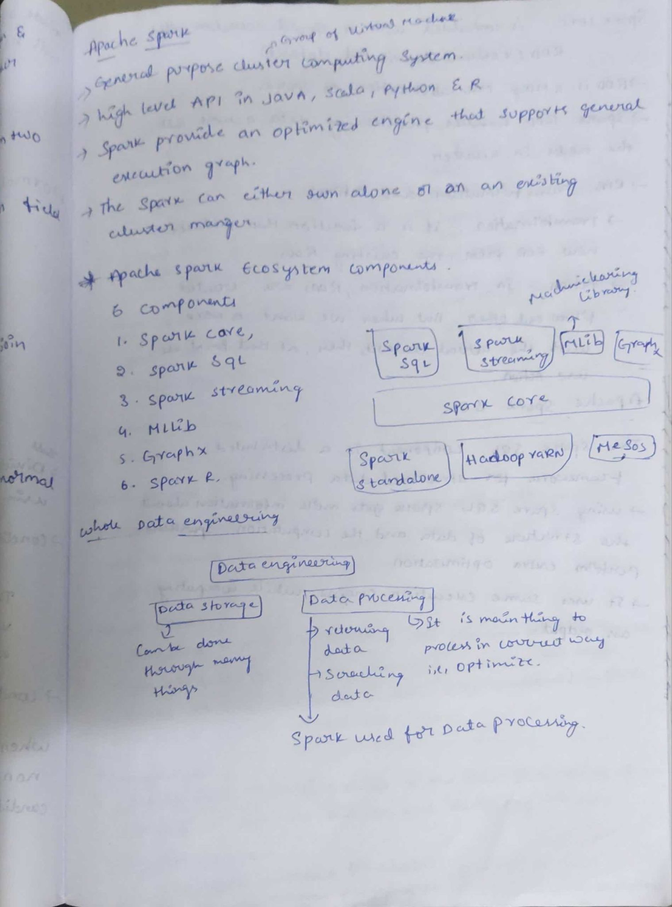

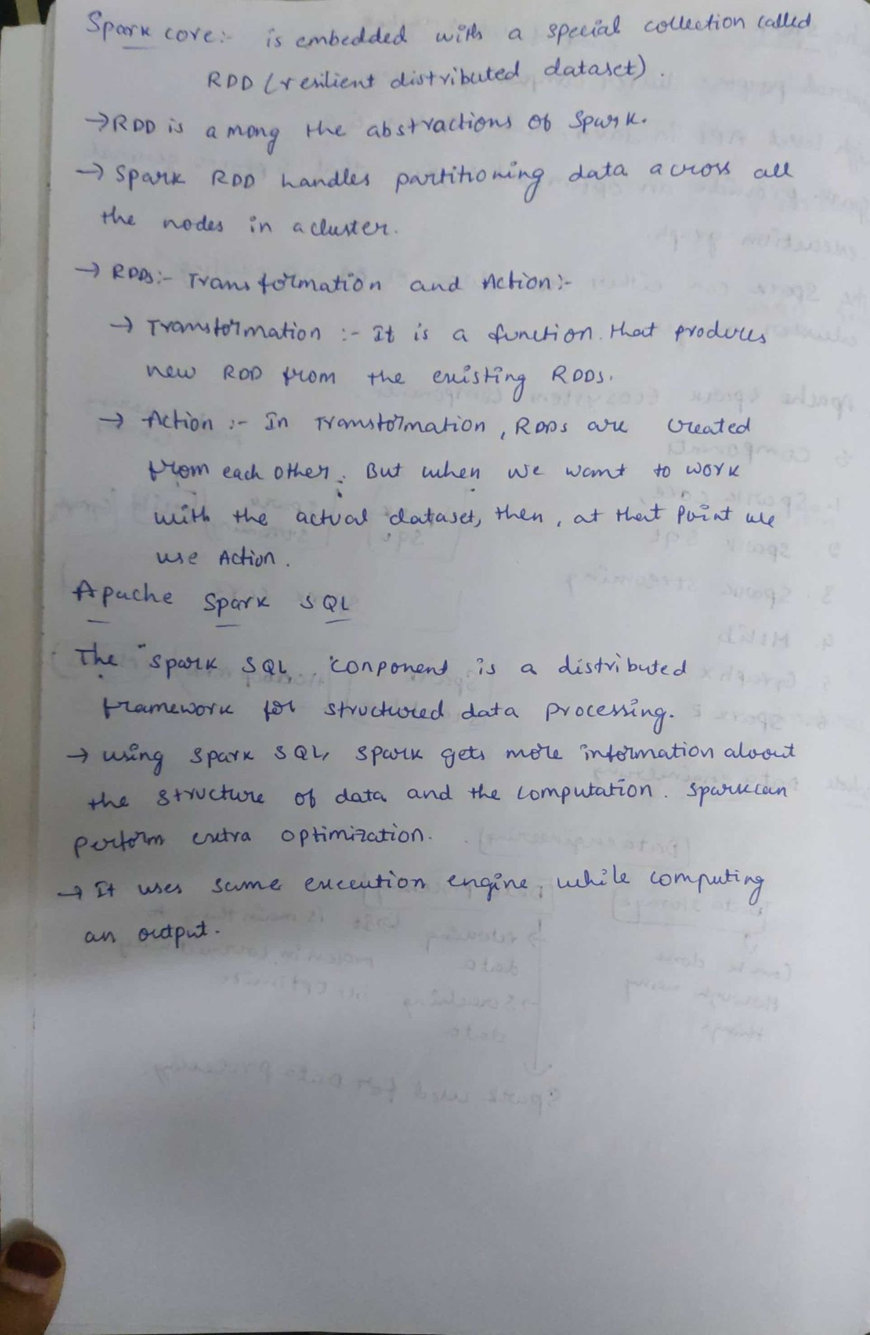

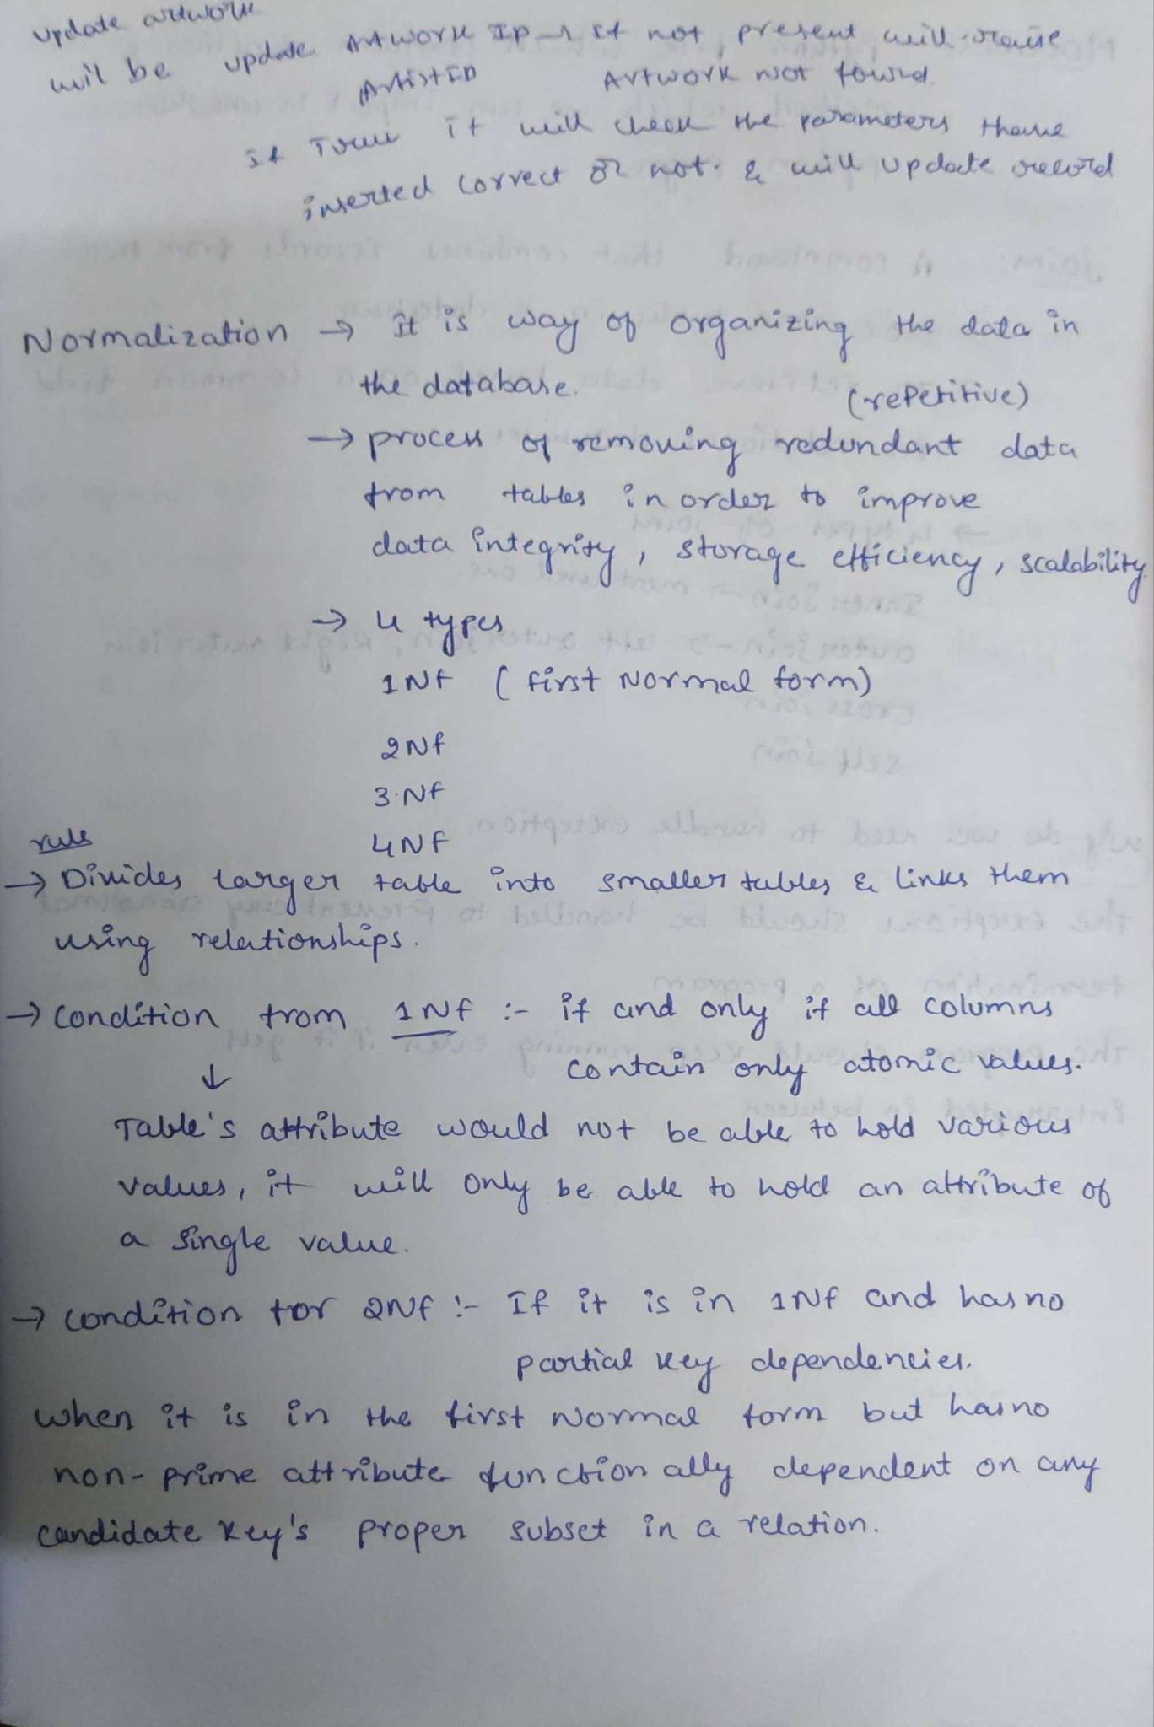

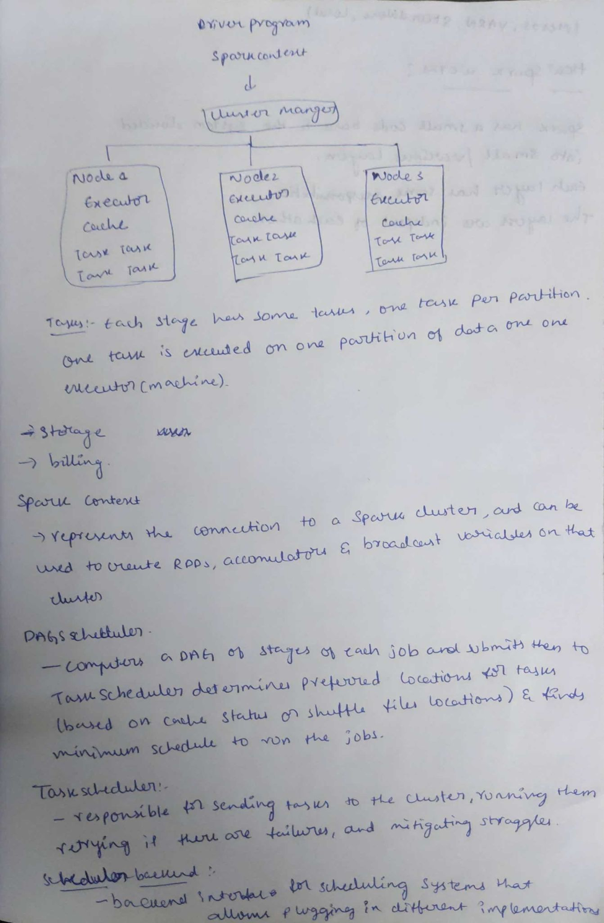

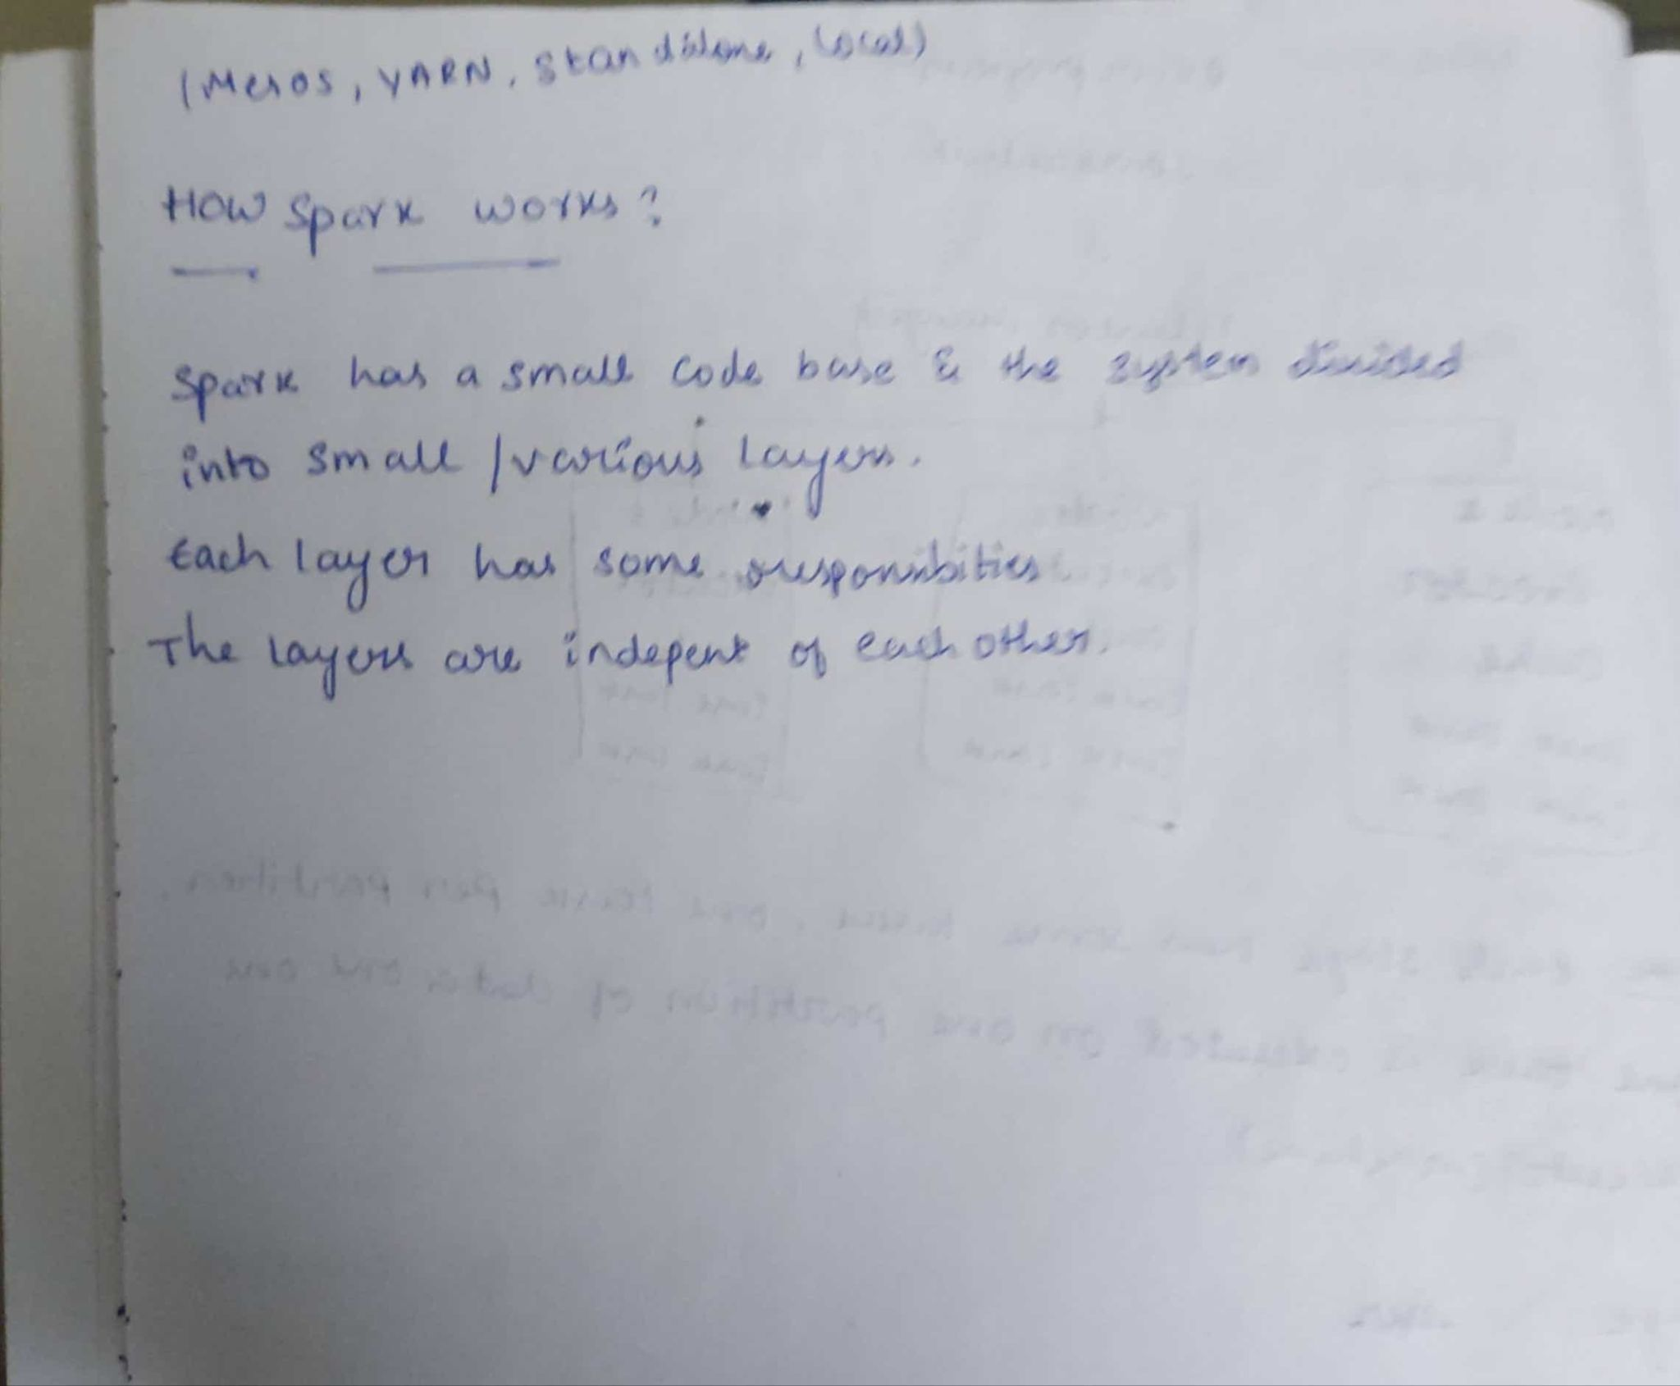

Python

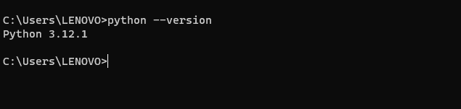

Java jdk

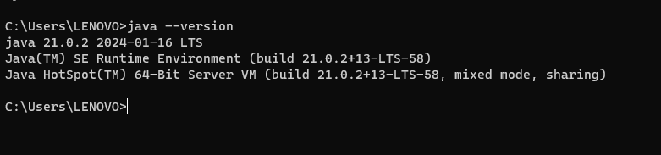

Apache Spark

